Brent Mortimer
brent.e.mortimer@usace.army.mil
Abstract
This Aquatic Pesticide Application Plan is the guiding document for all aquatic plant management activities for calendar year 2023.
2023 Aquatic Pesticide application Plan
US Army Corps of Engineers Lake Seminole, FL/GA

Contents
BACKGROUND INFORMATION: 2
Permit Coverage 3
Limitations of Coverage 4
Water of the U.S. 5
Water Quality Standards 7
Effluent Limitations 7
MONITORING REQUIREMENTS 9
DESCRIPTION OF THE WATER SYSTEM……………………………………………10
Figure 1: Geographical extant of Lake Seminole FL/GA………………………………...10
DESCRIPTION OF THE TREATMENT AREAS: 11
Figure 2: Example of Aquatic Weeds on Lake Seminole FL/GA 11
Table 1: Treatment Areas 12
Figure 3: Map Plates 16
Application schedule 16
Public notice requirement 17
AQUATIC PESTICIDES AND ADJUVANTS THAT MAY BE USED AND APPLICATION METHODS 17
Factors influencing weed control 18
REPORTING: 19
Annual/Biennial Report 19
DESCRIPTION OF BEST MANAGEMENT PRACTICES (BMPs) TO BE IMPLEMETED 19
EXAMINATION OF AQUATIC VEGETATION CONTROL ALTERNATIVES 22
Watershed management and the runoff impacts 22
Watershed management 24
Biological control 24
Physical control 25
INTEGRATED AQUATIC VEGETATION CONTROL RECOMMENDATIONS 26
SHORELINE PERMIT HOLDERS 27
APAP UPDATES 27

BACKGROUND INFORMATION:

Plants are an important part of the aquatic ecosystem, providing habitat, food, bank protection, temperature stabilization, oxygen production, etc. When non-native, invasive aquatic plants are introduced into these aquatic ecosystems they disrupt the balance between the native plants and aquatic organisms through their rapid growth, monoculture growth, and lack of natural predators. The various non-native, invasive aquatic plants in Lake Seminole have negative impacts such as, degradation of fish and wildlife habitat, loss of habitat, deterioration of wetlands and water quality, reduced surface area for recreation, lower property values, impeding navigation, clogging water supply lines, and causing flooding.

The following Laws, Regulations, and Policy provide the authorization for the treatment invasive species: National Invasive Species Act of 1996, Executive Order 13112, Executive Order 13751, Engineer Regulation 1130-2-540, and USACE Invasive Species Policy dated June 2, 2009.

The Record of Decision for the Lake Seminole Hydrilla Action Plan GA-FL dated June 1998 is the controlling document for management activities associated with hydrilla. This document and the associated Final Supplement to the Master Plan and Final Supplement to the Environmental Impact Statement define a general plan for hydrilla management activities on Lake Seminole. All hydrilla control activities for 2023 will be within the guidelines of this document. The Final Supplement to the Master Plan and Final Supplement to the Environmental Impact Statement (EIS) did not address other nuisance aquatic plant management species, e.g., water hyacinths, giant cutgrass, Cuban bulrush, American lotus, fanwort, etc., other than in general terms of acceptable percent of aquatic plant coverage for the four management compartments (Chattahoochee River, Flint River, Spring Creek, and Fish Pond Drain) on the lake. Management of these types of invasive aquatic plants was addressed in two earlier EISs – 1) Lake Seminole and Jim Woodruff Lock and Dam, AL-FL, and GA, Operation and Maintenance Final Environmental Impact Statement, 1976, and 2) Aquatic Plant Control Program, Mobile District, Final Environmental Impact Statement, 1978.

This Aquatic Pesticide Application Plan (APAP) is a comprehensive plan developed by the discharger to comply with the provisions of State General National Pollutant Discharge Elimination System Permits for Aquatic Pesticide Discharges to Waters of the United States from Algae and Aquatic Weed Control Applications, General Permit No. FLG510064 effective December 20, 2021, and GAG820066 effective August 1, 2021.

This APAP describes the aquatic plant and algae nuisances, aquatic pesticide products expected to be used, the monitoring program, and Best Management Practices to be followed, as well as the other conditions addressed in the General Permit.

The use of aquatic pesticides within and adjacent to Lake Seminole is necessary to manage for the Congressionally authorized uses of the lake: hydropower, navigation, recreation, and related-use purposes. The Aquatic Vegetation Control Program is an undertaking necessary to control specific types of aquatic vegetation that have become a nuisance to the management of the water body and are impacting its health and authorized uses. The need for aquatic pesticide application events as part of this program vary from week to week and from season to season due to such things as water temperature, sunlight, nutrient levels, plant and algae growth and other factors.

This APAP per the General Permit requirements described below provides the outline to ensure that the Aquatic Vegetation Control Program is successful.

PERMIT COVERAGE:
The General Permit (No. FLG510064 and GAG820066) addresses the discharge of registered pesticides into and adjacent to the waters of the States of Florida and Georgia.

LIMITATIONS OF COVERAGE:
    - This general permit does not apply to the application of pesticides to areas which do not require a National Pollutant Discharge Elimination System (NPDES) permit, including:

      - Any introduction of pollutants from non-point source agricultural and silvicultural activities including storm runoff from orchards, cultivated crops, pastures, and forest lands; and

      - Return flows from irrigated agriculture.

    - Section 305(b) of the Clean Water Act (CWA) requires States to assess and describe the quality of its waters every two years in a report called the 305(b} report. Section 303(d) of the CWA requires States to submit a list of all waters that are not meeting their designated uses. For the purposes of this permit, impaired waters are those that have been identified by the State of Florida pursuant to Chapter 62-303, (F.A.C.) and Georgia pursuant to Section 303(d) of the CWA as not meeting applicable State surface water quality standards.

Point source discharges from a pesticide application to waters of the State are not eligible for coverage under this permit if the water is identified as impaired for that pesticide or its degradants. A list of these waters is available on DEP’s website: https://floridadep.gov/dear/water-quality-restoration/content/impaired-waters-tmdls-and-basin-management-action-plans, EPD’s website: https://epd.georgia.gov/document/document/ga2020305b303dlistofwaters/download

    - Discharges to Waters Designated as Outstanding National Resource Waters (ONRW) in Rule 62-302.700, F.A.C. and ratified by the Florida legislature are not eligible for coverage under this permit.

    - Discharges currently or previously covered by another Permit. Coverage under this permit is not allowed if any of the following circumstances apply:

      - The discharges are covered by another NPDES permit, or

      - The discharges were included in a permit that within the last five years has been denied, terminated, or revoked by the DEP.

    - Point source discharges from pesticide application to waters of the State that are currently or previously covered by another permit are not eligible for coverage under this permit if any of the following circumstances apply:

      - The discharges are covered by another NPDES permit; or

      - The discharges were included in a permit that within the last five years has been denied, terminated, or revoked by the DEP or EPD.

MS4 Stormwater NPDES permits cover non-point source discharges, therefore permit holders for MS4 NPDES permits are eligible for coverage under this general permit for the point source discharge of pesticides to waters of the State. Prior to the issuance date of this permit, EPD did not issues NPDES permits for the application of pesticides to waters of the State.

WATERS OF THE UNITED STATES: The General Permit regulates the discharge of pesticides associated with the application of aquatic pesticides to waters of the United States. “Waters of the United States” are defined by the General Permit as follows:
- All waters which are currently used, or were used in the past, or may be susceptible to use in interstate or foreign commerce, including all waters which are subject to the ebb and flow of the tide;
- All interstate waters including interstate wetlands;
- All other waters such as intrastate lakes, rivers, streams (including intermittent streams), mudflats, sandflats, wetlands, sloughs, prairie potholes, wet meadows, playa lakes, or natural ponds, the use, degradation or destruction of which could affect interstate or foreign commerce including any such waters:
- Which are or could be used by interstate or foreign travelers for recreational or other purposes; or
- From which fish or shellfish are or could be taken and sold in interstate or foreign commerce; or
- Which are used or could be used for industrial purpose by industries in interstate commerce;
- All impoundments of waters otherwise defined as waters of the United States;
- Tributaries of waters identified in paragraphs (1) - (4):
- The territorial seas; and
- Wetlands adjacent to waters (other than waters that are themselves wetlands) identified in paragraphs (1) - (6).
- Waste treatment systems, including treatment ponds or lagoons designed to meet the requirements of CWA (other than cooling ponds as defined in 40 C.F.R. section 423.11(m) which also meet the criteria of this definition) are not waters of the United States. This exclusion applies only to manmade bodies of water which neither were originally created in waters of the United States (such as disposal area in wetlands) nor resulted from the impoundment of waters of the United States [See Note 1 of this Section.] Waters of the United States do not include prior converted cropland. Notwithstanding the determination of an area’s status as prior converted cropland by any other federal agency, for the purposes of the Clean Water Act, the final authority regarding Clean Water Act jurisdiction remains with U.S. EPA.

WATER QUALITY STANDARDS: The Clean Water Act (CWA) defines Water Quality Standards as “Provisions of state or federal law which consist of designated uses for the waters of the United States, water quality criteria for waters based upon such uses, and antidegradation policies. Water quality standards are to protect the public health or welfare, enhance the quality of water and serve the purposes of the Act.” [40 Code of Federal Regulations (CFR) section 131.3(i)].

The Federal Clean Water Act provides the statutory basis for state water quality standards programs. The regulatory requirements governing these programs (Water Quality Standards Regulation) are published in 40 CFR 131. States are responsible for reviewing, establishing and revising water quality standards. Florida’s surface water quality standards system is published in 62-302 (and 62-302.530) of the Florida Administrative Code (F.A.C.) and Georgia’s water quality standards is published in Georgia’s Rules and Regulations for Water Quality Control (Chapter 391-3-6-.03).

EFFLUENT LIMITATIONS: NPDES permits for discharges to surface waters must meet all applicable provisions of sections 301 and 402 of the CWA. These provisions require controls that utilize best available technology economically achievable (BAT), best conventional pollutant control technology (BCT), and any more stringent controls necessary to reduce pollutant discharge and meet water quality standards.

Title 40, CFR section 122.44 states that if a discharge causes, has the reasonable potential to cause, or contributes to an excursion (Reasonable Potential) of a numeric or narrative water quality criterion, the permitting authority must develop effluent limits as necessary to meet water quality standards. Title 40, CFR section 122.44(k)(3) allows these effluent limits to be requirements to implement BMPs if numeric effluent limits are infeasible. It is infeasible for the State Board to establish numeric effluent limitations in this General Permit because the application of aquatic pesticides is not necessarily considered a discharge of pollutants according to the Talent decision. The regulated discharge is the discharge of residues associated with the application of aquatic pesticides. These include over-applied and misdirected pesticide product and pesticide residue. At what point the pesticide becomes a residue is not precisely known and varies depending on such things as target weed, water chemistry, and flow. Therefore, the effluent limitations contained in the General Permit are narrative and include requirements to develop and implement a Pesticide Discharge Management Plan (PDMP) and the Annual Plan that describes appropriate BMPs, including compliance with all pesticide label instructions, and to comply with receiving water limitations.

The BMPs required herein constitute Best Available Technology (BAT) and Best Conventional Technology (BCT) and will be implemented to minimize the area and duration of impacts caused by the discharge of aquatic pesticides in the treatment area, and to allow for the restoration of water quality and protection of beneficial uses of the receiving waters to pre-application quality following completion of a treatment event.

Once an aquatic pesticide has been applied to an application area, the pesticide product can actively treat the target species within the treatment area. During the treatment event, the aquatic pesticide is at a sufficient concentration to actively kill or control the target weeds plants or algae. When active ingredient concentrations are below this effective concentration, the aquatic pesticide becomes a residue. The minimum effective concentration, and the time required to reach it, vary due to site specific conditions, such as flow, target species, and water chemistry. The Receiving Water Limitations require that an application event does not result in an exceedance of water quality standards in the receiving water. The receiving water includes:

- Anywhere outside of the treatment area at any time, and
- Anywhere inside the treatment area after completion of the treatment event.

In recognition of the variability in the temporal extent of a treatment event, the General Permit does not require monitoring to be discretely defined. Instead, post-event monitoring of the water is required after enough time has elapsed for the results of aquatic pesticide application to be seen.

MONITORING REQUIREMENTS:

The General Permit requires dischargers to comply with the Monitoring and Reporting Program (MRP). The goals of the MRP are to:
  - Identify and characterize algaecide or aquatic herbicide application projects conducted by the Discharger;
  - Determine compliance with the receiving water limitations and other requirements specified in this General Permit;
  - Measure and improve the effectiveness of the Plan;
  - Support the development, implementation, and effectiveness of BMPs;
  - Assess the chemical, physical, and biological impacts on receiving waters resulting from algaecide or aquatic herbicide applications;
  - Conduct visual spot checks during any pesticide application and any post-application surveillance or efficacy check, and
  - Conduct annual reporting for DEP and biennial reporting for EPD.

This Plan was prepared to address the above requirements and those detailed in the General Permit.

DESCRIPTION OF THE WATER SYSTEM:

Lake Seminole is maintained by the US Army Corps of Engineers.
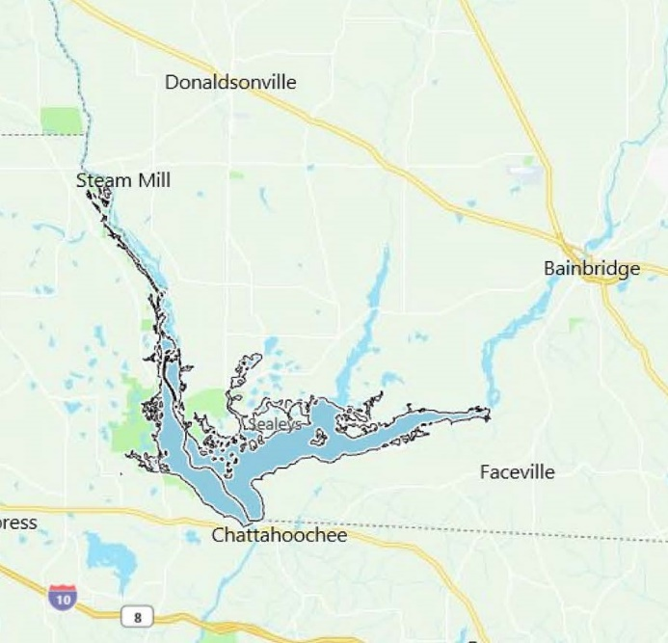
Figure 1: Geographical extent of Lake Seminole GA-FL

Nuisance growths of aquatic vegetation within Lake Seminole have caused varying levels of negative impacts on the beneficial uses of the system. Uncontrolled vegetation restricts navigation, hydropower generation, recreational use, water flows and reduces fish and wildlife habitat. The US Army Corps of Engineers has been applying herbicides to the vegetation since the 1970s to ensure that nuisance growths of aquatic vegetation do not impact the beneficial uses of the lake.

DESCRIPTION OF THE TREATMENT AREAS:

Depending on the season, many areas of the lake are impacted by nuisance growths of floating, emergent, and submerged aquatic vegetation. The primary aquatic vegetation impacting the lake is Hydrilla (Hydrilla verticillata), Water Hyacinth (Eichhornia crassipes), Varible-leaf Watermilfoil (Myriophyllum heterophyllum), Eurasian Watermilfoil (Myriophyllum spicatum), Giant cutgrass (Zizaniopsis miliacea), Common Reed (Phragmites australis), Cuban Bulrush (Oxycaryum blepharoleptos), Alligatorweed (Alternanthera philoxeroides), Fanwort (Cabomba caroliniana), Asian Marshweed (Limnophila sessiliflora), East Indian Hygrophila (Hygrophila polysperma), American lotus (Nelumbo lutea), Torpedograss (Panicum repens), Common Salvinia (Salvinia minima), pondweed species (Potomogeton sp), cattail species (Typha sp), and water primrose species (Ludwigia sp). Other species may be introduced, which will be a priority to prevent establishment. Algae species may be targeted in the future should they develop to nuisance levels. The total combined surface acreage of the lake is 37,500 Acres. As much as 60% of the lake has been impacted with aquatic vegetation growth.

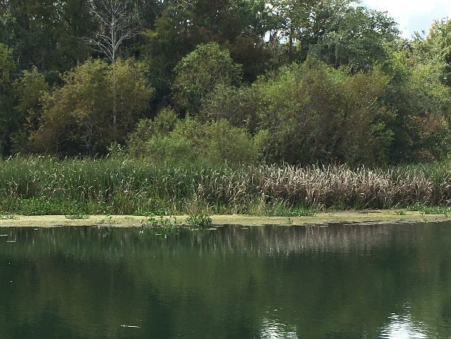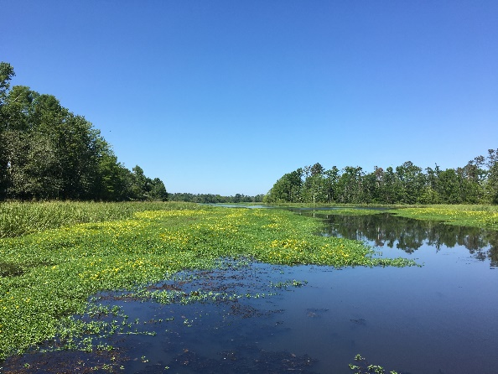
Figure 2: Aquatic Weeds on Lake Seminole FL/GA

Table 1: Treatment Areas

Area Name | Acreage | Map Plate | Target Plant | Comments
Acorn Drive Canal | 3 | 21 | Limnophila, milfoil | Access
Apalachee WMA | 714 | 11, 19, 20 | Phragmites, cutgrass, Cuban bulrush | Access, Recreation
At Ease Marina | 21 | 23 | Hydrilla, Cabomba, primrose, cutgrass, Cuban bulrush | Marked small boat channel, recreation, boat ramp, marina
Bluebird Pond Channel | 7 | 22 | Hydrilla, pondweed | Marked small boat channel, Recreation
Brockett’s Slough | 48 | 23,24 | Hydrilla, milfoil, Cuban bulrush | Marked small boat channel, Recreation
Buena Vista Upper | 25 | 46,55 | Hydrilla, cutgrass | Recreation, access
Buena Vista West | 16 | 46 | Hydrilla, cutgrass | Recreation, access
Bully Arnold North Lower | 11 | 29 | Hydrilla, Limnophila, primrose, Cuban bulrush, cutgrass | Recreation, boat ramp access to river
Bully Arnold North Upper | 9 | 29 | Hydrilla, primrose, Cuban bulrush, cutgrass | Recreation, boat ramp access to river
Bully Arnold Ramp | 3 | 29 | Hydrilla, Cabomba, watershield, cutgrass | Recreation, boat ramp
Bully Arnold River | 11 | 29 | Hydrilla, Limnophila, Cuban bulrush,cutgrass | Recreation, access
Chattahoochee Park Canal | 3 | 12 | Milfoil, hydrilla, cutgrass, primrose, Cuban bulrush | Recreation
Chattahoochee Park Ramp | 4 | 12 | Hydrilla | Boat ramp
Corps Boat Basin | 3 | 3 | Hydrilla, coontail, primrose | Operations, Corps boat house
Corps Boat Basin Channel | 2 | 3 | Hydrilla | Operations, Boat Basin access
Cypress Pond | 35 | 21 | Milfoil, Limnophila, pondweed, Cuban bulrush | Channel, access
Area Name | Acres | Map Plate | Target Plant | Comments
Cypress Pond Barrier | 4 | 21 | Hydrilla, Cabomba, Limnophila, pondweed | Operations, electric barrier
Desser | 2 | 47 | Hydrilla, Cabomba, Limnophila, cutgrass, hyacinth, Cuban bulrush | Recreation, boat ramp
Desser Lower Westside | 24 | 47 | Hydrilla, hyacinth, cutgrass, Cuban bulrush | Access
Desser Ramp | 2 | 47 | Hydrilla, hyacinth, cutgrass, Cuban bulrush | Marked small boat channel, Recreation, boat ramp
Desser Upper | 20 | 47 | Hydrilla, hyacinth | Access
Eastbank CG Canal | 1 | 3 | Hydrilla, milfoil, pondweed | Recreation, access
Eastbank CG Ramp | 7 | 3 | Hydrilla, milfoil, pondweed | Recreation
Faceville Landing | 5 | 25 | Hydrilla, primrose, Cuban bulrush, hyacinth | Marked small boat channel, Recreation, Boat ramp, Campground
Fairchild’s Ramp | 13 | 29 | Hydrilla, cutgrass, Cuban bulrush | Marked small boat channel, Recreation, boat ramp
Fairchild’s Slough | 41 | 29 | Hydrilla, pondweed, Cabomba, cutgrass, Cuban bulrush | Recreation, access
Fireman's Cut | 26 | 22,23 | Hydrilla, Cabomba, cutgrass, Cuban bulrush | Marked small boat channel access from Flint River to Spring Creek
FPD Barrier | 5 | 30 | Hydrilla, Limnophila, primrose | Operations, electric barrier, Limnophila
FPD Lower Section 1 | 11 | 21 | Hydrilla, Cabomba | Marked small boat channel, Recreation
FPD Lower Section 2 | 11 | 21 | Hydrilla, Cabomba | Marked small boat channel, Recreation
FPD Lower Section 3 | 13 | 21 | Hydrilla, Cabomba | Marked small boat channel, Recreation
FPD Lower Section 4 | 11 | 21 | Hydrilla,Cabomba | Marked small boat channel, Recreation
Area Name | Acres | Map Plate | Target Plant | Comments
FPD Lower Section 5 | 11 | 21 | Hydrilla, Cabomba | Marked small boat channel, Recreation
FPD Lower Section 6 | 21 | 21 | Hydrilla, Cabomba | Marked small boat channel, Recreation
FPD Upper Section 1 | 6 | 30 | Hydrilla, Limnophila, milfoil, primrose | Marked small boat channel, Recreation, boat ramp
FPD Upper Section 2 | 27 | 21,30 | Hydrilla, Limnophila, milfoil, primrose | Marked small boat channel, Recreation, boat ramp
Frog Pond Channel | 6 | 21 | Limnophila, hydrilla, primrose | Marked small boat channel, Recreation, boat ramp
Goat Island | 29 | 23 | Hydrilla, primrose, cutgrass, Cuban bulrush | Access
Hickory Pond | 6 | 21 | Limnophila, pondweed, Bacopa | Recreation, access
Hickory Pond Barrier | 6 | 22 | Hydrilla | Operations, electric barrier
Holly Isles Canal | 10 | 21 | Limnophila, milfoil | Access
Holly Isles Bridge | 10 | 21 | Limnophila, pondweed | Marked small boat channel, Recreation, boat ramp
Howells Ramp | 7 | 11 | Hydrilla, cutgrass, phragmites | Boat ramp
Kelly’s Slough | 12 | 23 | Cabomba, hydrilla, cutgrass, primrose | Access
Lewis Pond | 275 | 30 | Limnophila, hydrilla, cutgrass, Cuban bulrush, milfoil | Marked small boat channel, Recreation
Little Dothan | 3 | 38 | Hydrilla, cutgrass | Access
Parramore Run | 9 | 38 | Hydrilla, cutgrass, primrose | Marked small boat channel, Recreation, boat ramp
Pear Orchard Head | 14 | 10 | Hydrilla, cutgrass, primrose, Cuban bulrush | Recreation, access
Area Name | Acres | Map Plate | Target Plant | Comments
Pear Orchard Lower | 11 | 11 | Hydrilla, cutgrass, primrose | Recreation, access
Pear Orchard Middle | 10 | 11 | Hydrilla, Cabomba, | Recreation, access
Pear Orchard Upper | 8 | 11 | Hydrilla, Cabomba, Naiad | Recreation, access
Pickle Slough | 23 | 30 | Limnophila, hydrilla, cutgrass, cattail, Cuban bulrush, hyacinth | Recreation, access
Ranger Station Inner | 4 | 20 | Hydrilla, cutgrass, Cuban bulrush, primrose | Operations, marked small boat channel, recreation
Ranger Station Outer | 5 | 20 | Hydrilla, cutgrass, Cuban bulrush, primrose | Operations, marked small boat channel, recreation
Rays Lake | 11 | 30 | Hydrilla, milfoil, pondweed, hyacinth, primrose | Marked small boat channel, recreation, fishing pier, boat ramp
River Junction Ramp | 5 | 12,13 | Hydrilla, pondweed | Marked small boat channel, recreation, boat ramp
Sealy Ramp | 2 | 21 | Hydrilla | Marked small boat channel, recreation, boat ramp
Sealy Run | 8 | 12,21 | Hydrilla | Marked small boat channel, recreation
Seminole Lodge and Channel | 9 | 11 | Hydrilla, hygrophila, cutgrass, primrose, phragmites, Cuban bulrush | Marina, marked small boat channel, recreation, boat ramp
Seminole State Park | 25 | 21,30 | Hydrilla, Limnophila | Marked small boat channel, recreation, boat ramp
Sneads Park | 22 | 11 | Hydrilla, primrose, Cuban bulrush, phragmites | Recreation, boat ramp
Spring Creek Park Channel | 6 | 22,31 | Hydrilla, Cabomba, milfoil, Giant bulrush, hyacinth | Marked small boat channel
Spring Creek Park East | 6 | 31 | Hydrilla, Cabomba, cutgrass, lotus, water lily | Recreation, boat ramp
Spring Creek Park Marina | 4 | 31 | Hydrilla, Cabomba, milfoil, Limnophila, primrose | Recreation, marina
Area Name | Acres | Map Plate | Target Plant | Comments
Spring Creek Park West | 8 | 31 | Hydrilla, pondweed, Cabomba | Recreation
Spring Creek Run | 114 | 12, 21,22,31,32,41 | Hydrilla, hyacinth, cutgrass, Cuban bulrush, primrose | Marked small boat channel, recreation
Three Rivers State Park | 38 | 11 | Hydrilla, cutgrass, Cuban bulrush, cattail, phragmites | Recreation, fishing pier, access
Trails End Marina | 8 | 20 | Hydrilla, Cabomba, Limnophila, Cuban bulrush, cutgrass, primrose | Marked small boat channel, recreation, boat ramp, marina
Turkey Pond | 21 | 21 | Limnophila, hydrilla | Recreation, access
Turkey Pond Drain | 34 | 21 | Limnophila, hydrilla, pondweed | Marked small boat channel, recreation
Highlighted areas are included in the collaborative action plan with Stewards of Lake Seminole.

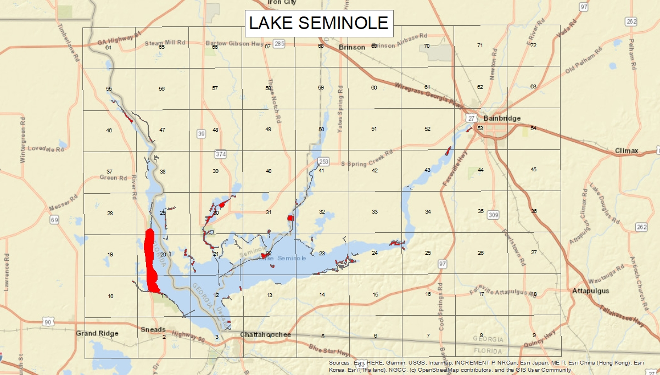
Figure 3: Map Plates
APPLICATION SCHEDULE: The US Army Corps of Engineers Aquatic Plant Manager determines the areas of the lake to be treated based on knowledge, surveys, upcoming operations, and stakeholder input. The treatment is based on the management goals of Lake Managers, location, timing, herbicide inventory, and funding. These applications are made through the Operation and Maintenance contractor’s certified aquatic pesticide applicators, certified USACE staff, and outside contractors with available funding. Due to the number of treatments and acreages covered, timing and locations will be approximate. USACE will work with the Stewards of Lake Seminole to coordinate treatments if possible.

PUBLIC NOTICE: Every calendar year by January 31st the Plan is completed and posted to the Woodruff/Seminole project website. Location of the application may change without notice due to on site conditions and other factors.

AQUATIC PESTICIDES AND ADJUVANTS THAT MAY BE USED AND
APPLICATION METHODS: Provided in the table below are the aquatic pesticides that may be used in the aquatic plant control program within the lake. The need for treatments is based on aquatic vegetation growth and visual monitoring.

Herbicide/Algaecide* | Swimming Restrictions | Fish Consumption Restrictions | Irrigation Turf and Food Crop Restrictions | Adjuvant
2,4-D Amine | 0 days | 0 days | 3 weeks or 0.1 ppm or less | Aquatic Labeled
Flumioxazin | 0 days | 0 days | 3 Days | Aquatic labeled 80% non-ionic surfactant
Copper Complexes (Copper sulfate, Chelated Copper) | 0 days | 0 days | 0 days | Aquatic labeled d-limonene or similar surfactant
Diquat Dibromide | 0 days | 0 days | 3-5 Days | Aquatic labeled surfactant
Endothall | 0 days | 0 days | 0 days | Not Applicable
Fluridone | 0 days | 0 days | 14 Days | Not Applicable
Glyphosate | 0 days | 0 days | 0 days | Aquatic labeled 50% min non-ionic surfactant
Imazamox | 0 days | 0 days | Less than or equal to 50 ppb | Aquatic labeled surfactant
Imazapyr | 0 days | 0 days | 120 Days or less than or equal to 1 ppb | Aquatic labeled surfactant
Herbicide/Algaecide* | Swimming Restrictions | Fish Consumption Restrictions | Irrigation Turf and Food Crop Restrictions | Adjuvant
Penoxsulam | 0 days | 0 days | Less than or equal to 1 ppb | Aquatic labeled surfactant
Triclopyr | 0 days | 0 days | 120 Days or until  Non-detectable by immunoassay test | Aquatic non-ionic surfactant
Carfentrazone | 0 days | 0 days | 14 days | MSO or non-ionic surfactant
Bispryribac-sodium | 0 days | 0 days | Less than or equal to 1 ppb | Aquatic labeled 80% non-ionic surfactant
Florpyrauxifen-benzyl | 0 days | 0 days | Up to 35 days or use FasTEST | MSO

*Refer to Product Labels and SDS’s for Further Information

Aquatic pesticide applications will be performed utilizing Best Management Practices (BMP’s) by licensed personnel in accordance with laws and regulations of the state in which the application occurs. All aquatic herbicide applications would be performed by contractors or USACE staff with valid applicator licenses, or under the direct supervision of a certified applicator. Applications targeting floating and emergent vegetation would be performed using a handgun sprayer or boom operated from a boat, shore-based trailer, or helicopter. Applications targeting submerged aquatic vegetation would be performed from a boat utilizing subsurface injection system, broadcast spreader, helicopter or a shore-based injection system (i.e.: Spring Creek injection delivery).

FACTORS INFLUENCING WEED CONTROL: The decision to implement aquatic vegetation control applications is based on the plant’s growth stage prior to treatment and re-evaluated at the time of the application. Based on nuisance levels of aquatic vegetation growth and its potential to impact beneficial uses of the lakes systems, the Aquatic Plant Manager (APM) with input from the stakeholders will review control options. Based on the APM’s findings, a Pest Control Recommendation (PCR) will be developed for any aquatic pesticide applications. Aquatic herbicide applications are determined based on the following characteristics:
- The USACE will continually monitor the lake for aquatic vegetation growth. Prior to aquatic vegetation growth developing to nuisance levels, aquatic vegetation control measures will be scheduled.
- Which priority level is the area?

REPORTING:

Annual/Biennial Report: All reports will be submitted to the DEP or EPD. The Annual reports will contain the following information:
- Permittee Name;
- NPDES Pesticide General Permit Number;
- Responsible Person;
- Treatment Summary;
- Identification of Waters;
- Use Pattern;
- Weeds Treated;
- Types and Amounts (in pounds) of Algaecides and Aquatic Herbicides Used at Each Application Event;
- Applicator Name;
- Was the Application Expressed in the PDMP;
- Report of Adverse Incidents;
- Description of Corrective Actions and Rational for the Action.

Data Storage: All data will be recorded on supplied forms and entered into an herbicide application database on the Lake Seminole network server.

DESCRIPTION OF BEST MANAGEMENT PRACTICES (BMPs) TO BE IMPLEMENTED:

A variety of approaches will be utilized to minimize the impacts of aquatic pesticides used while still achieving their goals.
- Techniques that help reduce pesticide impacts include:
  - Non-pesticide control methods as outlined below (Alternatives) have been attempted or considered.
  - Pre-Treatment surveys are carried out to identify potential treatment areas and timing
  - Adjustments will be made to treatment protocols based upon survey results
  - Choice of pesticides based on target weed, effectiveness, timing, water conditions
  - Aquatic Pesticide use rates will be per the EPA approved label
  - Partial water body treatments or split treatments will be utilized to minimize impacts that might otherwise occur
- From the aquatic herbicides available, the most effective and safest options have been selected for use in this program. The Aquatic Plant Manager (APM) and Herbicide application personnel (Qualified Applicators) know the strengths and weaknesses of the various available options and take them into consideration when choosing a treatment protocol for a specific site.
- In order to avoid inadvertent or accidental soil or water contamination from aquatic pesticides, application personnel follow the storage, transport, and spill control procedures per USEPA and label instructions.
- Over application is avoided by following the specific product labels for the aquatic pesticides used in the program. Algaecide and aquatic herbicide quantities required for each treatment are calculated at the office and only enough material to carry out the treatment is transported for the day’s application. Application equipment is routinely cleaned and maintained, and all label directions are followed as to acceptable application methods as well as weather conditions. Surface applications are not made in winds above 10 miles per hour.
- The various BMP’s being implemented ensures that the Aquatic Vegetation Control Program will meet the requirements of the general NPDES Permit for the use of aquatic pesticides.
- Licensing: All contractors and USACE staff that apply or supervise the application of aquatic pesticides are certified and or licensed by the state.
- Notification: As detailed elsewhere in this document, whenever pesticides are used that might lead to damage to irrigated crops (the most severe potential impact on beneficial uses caused by the program), potentially affected users in the area will be informed of the treatments so that means can be taken to avoid using the treated water for irrigation purposes.
- Site Evaluations: As has been detailed in this section and elsewhere, both preliminary and secondary site evaluations are a major aspect of the program, as represented by the extensive surveying carried out by the field crews.
- Alternative Treatments: Staff considers several potential alternative control strategies in every situation and will make use of non-herbicide options when conditions are suitable and funding allows.
- Treatment Conditions: Every application is made according to label directions. If there are conditions where it is determined that the treatment would be ineffective, applicators will wait for other conditions or use a different treatment method.
- Post-treatment: Surveys are also carried out for post-treatment assessment of treatment efficacy and non-target impacts. Survey crews are instructed to look for possible non- target impacts that can be seen with the naked eye, such as dead fish or damage to plants on the shoreline.
- The applicator follows all pesticide label instructions and any Use Permits issued by a Florida Department of Agriculture and Consumer Services and Georgia Department of Agriculture;
- The discharger’s applicators are licensed by the State, or work with or under the supervision of someone who is licensed;
- The discharger’s applicators comply with effluent limitations
- The discharger’s applicators will follow this Aquatic Pesticide Application Plan (APAP);
- The discharger’s applicators comply with applicable receiving water limitations; and
- The discharger’s applicators will comply with the monitoring and reporting requirements outlined in this APAP.

Aquatic Pesticide Use Requirements:
- License Requirements. Applicators will be licensed by Florida Department of Agriculture and Consumer Services or Georgia Department of Agriculture.
- Application Requirements. The pesticide will be consistent with FIFRA pesticide label instructions and any Use Permits issued by Florida Department of Agriculture and Consumer Services and Georgia Department of Agriculture.

EXAMINATION OF AQUATIC VEGETATION CONTROL ALTERNATIVES:

All appropriate aquatic plant management technologies within the context of the identified beneficial uses and impacted areas of the lake have been evaluated, and include all available cultural, biological, mechanical, and aquatic pesticide formulations.

Aquatic weed and algae control options have been broken down into four basic categories that include:
- Watershed Management
- Biological Control
- Physical and Mechanical Control
- Aquatic Algaecides and Herbicides
A discussion on each of the options follows:
Watershed Management and the Runoff Impacts: Watershed management is one of the most important control parameters as it deals with limiting nutrients and runoff into a water body from the watershed. It entails implementing practices in the watershed that will support the reduction of nutrient and other pollutant runoff into the system. In natural areas, 10 % is runoff and 50 to 60% is direct infiltration (Runoff Coefficients for the Rational Method of Estimating Rainfall (McCuen, 1989)).

- Runoff Impacts
  - Non-point source pollution poses the most serious threat to the water quality of the system.
  - Non-point pollution in runoff includes sediments, oil, anti-freeze, pesticides, yard wastes and pet and waterfowl droppings.

- Nutrient Effects
  - Increase in algae blooms
  - Odor problems
  - Depletion of oxygen supply
  - Fish kills
  - Decrease in water clarity
  - Increase in the amount of rooted aquatic plants growing in the shallow waters of a lake
  - Reduction in the recreational value of the lake hinders boating, fishing, and reduces overall aesthetics of the lake

Eutrophication Process and Impacts:
Impacts of Eutrophication
  - Fish kills due to low oxygen or high metals
  - Taste and odor problems, resulting in an increase in water treatment costs
  - Floating algae mats, decaying vegetation
  - Increased littoral vegetation in shallow areas
  - Mobilization of sediment bound metals and ions during anoxic conditions (e.g., copper, ammonia, iron, sulfur, phosphorus)
  - Increased temperature
  - Reduced water clarity
  - Nuisance algal blooms
  - Reduced dissolved oxygen in hypolimnion
  - Earlier onset and/or longer duration of periods of anoxia in hypolimnion

Several tools are available to control the use and misuse of the land surrounding a waterbody that includes:
- Comprehensive Plans to guide long-term growth;
- Storm Water and Surface Water Management Planning that considers data collection, land use, system site considerations, and design criteria for structures in setting goals for watershed runoff; and Rules for a system uses such as where, when and how a system can be used recreationally to control shoreline erosion, nutrient recirculation and overuse.
- Other administrative alternatives may include shoreline erosion and sedimentation control management programs. Education is still probably the best way to combat water quality issues.

Non-structural alternatives: best management practices, such as buffer strips around water bodies to filter out sediments and reduce nutrients, are examples of non-structural alternatives. Chemical inactivation/precipitation of in-lake phosphorus, chemical control of algae, dredging of accumulated sediments, and mechanical harvesting of aquatic vegetation are additional examples.

Structural alternatives: Storm water detention basins and wetland treatment systems are structural alternatives that detain runoff to control peak flow rates and control downstream flooding. They also allow pollutants to settle out of the water before reaching the waterbody. Diversion structures routing storm water away from the lake and in-lake aeration systems to oxygenate the water are other structural alternatives

Watershed Management: The DEP and EPD has implemented various Watershed Management Plans designed to limit the impacts that the surrounding areas are having on the watershed. A Watershed Management Plan alone will more than likely not provide enough nutrient limitations to avoid excessive aquatic vegetation growth.

Biological Control: There are very few biological control options for eliminating aquatic weeds and algae. Some of the biological controls being used are:

- Triploid Grass Carp (Ctenopharyngodon idella):
The triploid grass carp are confined within two areas, known as Fish Pond Drain and Cypress Pond with low voltage electric barriers. The Cypress Pond barrier was destroyed and the Fish Pond Drain barrier was damaged by Hurricane Michael in 2018. The carp barrier structures have been rebuilt but are not currently online as of publication of this plan. The carp barriers likely will be online early this spring with the grass carp being stocked shortly after it becomes online. Monitoring of the submersed vegetation within the confinement areas will continue. Hydrilla within the Fish Pond Drain area has expanded along with Eurasian milfoil and pondweed. Limnophila sessiliflora has expanded and herbicide treatments will occur inside the barriers for this plant. Native vegetation within the Cypress Pond area has not been reduced as significantly as in the Lewis Pond area.

Hydrilla Leaf-mining Fly (Hydreillia pakistanae):
There will not be new releases of the hydrilla leaf-mining fly within the confines of Lake Seminole in 2023. We do expect the existing hydrilla fly population to have minimal impact on the hydrilla that is topped out at the water surface.

Physical:

Aeration & Water Quality Alteration: Aeration has been used for decades to circulate water and increase Dissolved Oxygen within lake and pond systems. In stratified lake systems where the bottom layers are anoxic during the summer months, a properly designed aeration system will limit nutrient recycling by supporting aerobic bacteria that support nutrient breakdown in bottom waters and the hydrosoil. Aeration has proven to be a successful tool for reductions in planktonic algae growth in small lakes and reservoirs. Systems vary in size and style from fountains to bottom bubbler diffuser type systems to hypolimnetic units that oxygenate the lower water below the thermocline. Aeration is not normally used in reservoirs as they are not designed or beneficial for this type of system. Lake Seminole has various springs that supply cool oxygenated water to the system.

Shading/Light Attenuation: A basic environmental manipulation for algae control is light reduction or attenuation. Organic dye can be added to a lake or pond system and is usually a blend of blue and yellow dyes specifically designed to screen or shade portions of the sunlight spectrum (red-orange and blue-violet) required by underwater aquatic plant and algae growth.

This action effectively inhibits photosynthesis required for algae growth. Dyes are primarily effective at depths of 2 feet or greater. Dye is not a good option for reservoir systems as it would disperse too quickly to be effective and would shade out beneficial native plants.

Sediment Removal: Dredging is usually not performed solely for aquatic plant management but to restore water bodies that have been filled in with sediments, have excess nutrients, have inadequate hypolimnetic zones, need deepening, or require removal of toxic substances. However, water bodies that are very shallow due to sedimentation typically do have excess plant and algae growth. USACE is only authorized to dredge the navigation channel, small boat channels, and operational areas. Dredging these locations would not eliminate the floating vegetation and would temporarily suppress growth only in the dredged locations. Dredging the system would also be very expensive as it requires heavy equipment and significant upland disposal areas. Shoreline permit holders may be permitted to dredge sediment up to a certain number of cubic yards in accordance with the Shoreline Management Plan.

Mechanical: Mechanical control of aquatic plants is an authorized option. However, mechanical removal expensive, slow, and short in duration. There are situations where mechanical control may be utilized by USACE, particularly in areas that have been cutoff due to emergent growth. Specified Acts permits may be available from the USACE to shoreline permit holders wishing to utilize mechanical control equipment.

INTEGRATED AQUATIC VEGETATION CONTROL RECOMMENDATIONS:

The recommended control strategy includes establishment of treatment thresholds, monitoring protocols to determine when thresholds are exceeded, and protocols to implement control measures when thresholds are exceeded in compliance with Best Management Practices. The control recommendations to deal with exotic and nuisance aquatic vegetation species present within the systems have been determined based on survey results, and recommended schedules for aquatic vegetation control are outlined in the APAP. It is recommended that an integrated approach that includes both watershed management and aquatic herbicide treatments be initiated to control nuisance growths of aquatic vegetation prior to their impact the beneficial uses of the system.

SHORELINE PERMIT HOLDERS:
The USACE is not authorized to treat aquatic plants around private docks. Docks may receive the benefits from herbicide dispersal from aquatic plant treatments in adjacent areas. However, permits are available to shoreline permit holders for mechanical removal and herbicide treatments on USACE lands and waters using a certified aquatic pesticide applicator. Permits are available through the Aquatic Plant Manager at brent.e.mortimer@usace.army.mil.

APAP UPDATES: This APAP will be updated as the General Permit conditions change, any new algaecides or aquatic herbicides are added to the aquatic vegetation management program, or as new control technologies are developed and become available.

END OF APAP

